# Jointly Distributed Random Variables

Review Sections 3.1, 3.2, and 3.3 in Goldsman, D. & Goldsman, P. (2020). A First Course in Probability and Statistics. Lulu. [Download link](https://www.lulu.com/search?page=1&q=goldsman&pageSize=10&adult_audience_rating=00)

Other resources that are helpful when reviewing calculus (integration especially double integration may be helpful for this module) are:

[Paul’s Online Math Notes](https://tutorial.math.lamar.edu/)

[Double Integrals](https://tutorial.math.lamar.edu/Classes/CalcIII/DoubleIntegrals.aspx)

[Iterated Integrals](https://tutorial.math.lamar.edu/Classes/CalcIII/IteratedIntegrals.aspx)

[Double Integrals over General Regions](https://tutorial.math.lamar.edu/Classes/CalcIII/DIGeneralRegion.aspx)

[Khan Academy](https://www.khanacademy.org/)

[YouTube](https://www.youtube.com/results?search_query=Calculus)

<https://math.libretexts.org/Bookshelves/Calculus>

<https://stats.libretexts.org/Bookshelves>

# Why are Jointly Distributed Random Variables Important?

Having a solid and fundamental understanding of jointly distributed random variables is vital for simulation due to the interconnected nature of real-world systems. Here's why:

* Modeling Dependencies: In many simulations, variables do not act independently. For instance, the demand for a product might be related to its price. Jointly distributed random variables allow us to model and account for such dependencies or correlations between variables.
* Multivariate Outputs: Simulations can often produce multiple outputs. To fully understand the system's behavior, it's important to analyze how these outputs relate to each other. Joint distributions provide this understanding.
* Covariance and Correlation: These are measures derived from jointly distributed random variables, helping quantify the degree and direction of linear dependence between two random variables. This knowledge is crucial in fields like finance where assets' returns might be correlated.
* Marginal Distributions: Even if we have a joint distribution of two or more random variables, there are times we are interested in the distribution of just one of those variables. Understanding how to derive these marginal distributions from joint distributions is fundamental.
* Conditional Distributions: In many scenarios, we're interested in the distribution of a variable given the value of another variable. For instance, the probability of equipment failure given certain environmental conditions. Joint distributions allow us to derive these conditional distributions.
* Chain Dependencies: In complex simulations, one variable might depend on a second, which in turn depends on a third, creating a chain of dependencies. Joint distributions can help in capturing and analyzing such scenarios.
* Copulas: In advanced modeling, copulas are functions that describe the dependency structure between random variables, allowing for the decoupling of marginals from their dependencies. This concept is rooted in the study of jointly distributed random variables.
* Bayesian Inference: In Bayesian statistics, the concept of prior, likelihood, and posterior distributions revolves around joint and conditional distributions. Bayesian methods are frequently used in simulations to update beliefs in light of new data.
* Risk Management: In finance and insurance, it's crucial to understand how different risks interact. For example, the joint probability of two rare events can inform decisions around insurance policies or financial hedging.
* Optimization under Uncertainty: When optimizing in situations with multiple random variables, understanding their joint behavior is crucial. For instance, in portfolio optimization, the joint distribution of asset returns affects the portfolio's expected return and risk.
* Spatial and Temporal Models: In simulations dealing with space (like geostatistics) or time (like time-series analysis), the data points (random variables) at different locations or times are often not independent. Their joint distribution captures their dependencies.
* Agent-Based Models: In simulations where multiple agents interact, the outcomes for each agent can be seen as jointly distributed random variables, representing the collective system behavior.

Jointly distributed random variables are at the core of understanding, modeling, and analyzing systems where multiple variables interact or are interrelated. This understanding is essential for accurately capturing system dynamics, making informed decisions, and drawing reliable conclusions from simulations.

# Continuous Jointly Distributed RVs Example

Before looking at the [marginal distributions](https://en.wikipedia.org/wiki/Marginal_distribution), let’s see how to verify that the joint PDF is valid. To verify this, we can integrate over [](https://www.codecogs.com/eqnedit.php?latex=x#0) and [](https://www.codecogs.com/eqnedit.php?latex=y#0) to make sure it integrates to 1.

Also see the [M2 Additional Examples (#5)](https://docs.google.com/document/d/1qqz58yA48vsXSRKJ2QZ6BQITWTm7zLsr-kQBpve170E/edit?usp=sharing)

It’s useful to visualize the region defined by the bounds of [](https://www.codecogs.com/eqnedit.php?latex=x#0) and [](https://www.codecogs.com/eqnedit.php?latex=y#0). In this example that is [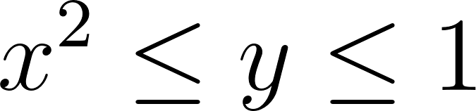](https://www.codecogs.com/eqnedit.php?latex=x%5E2%20%5Cleq%20y%20%5Cleq%201#0). The following graph shows this region. It is the region above the parabola and below the horizontal line. Note that [](https://www.codecogs.com/eqnedit.php?latex=x#0) can go from [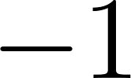](https://www.codecogs.com/eqnedit.php?latex=-1#0) to [](https://www.codecogs.com/eqnedit.php?latex=1#0) and [](https://www.codecogs.com/eqnedit.php?latex=y#0) can go from [](https://www.codecogs.com/eqnedit.php?latex=0#0) to [](https://www.codecogs.com/eqnedit.php?latex=1#0).

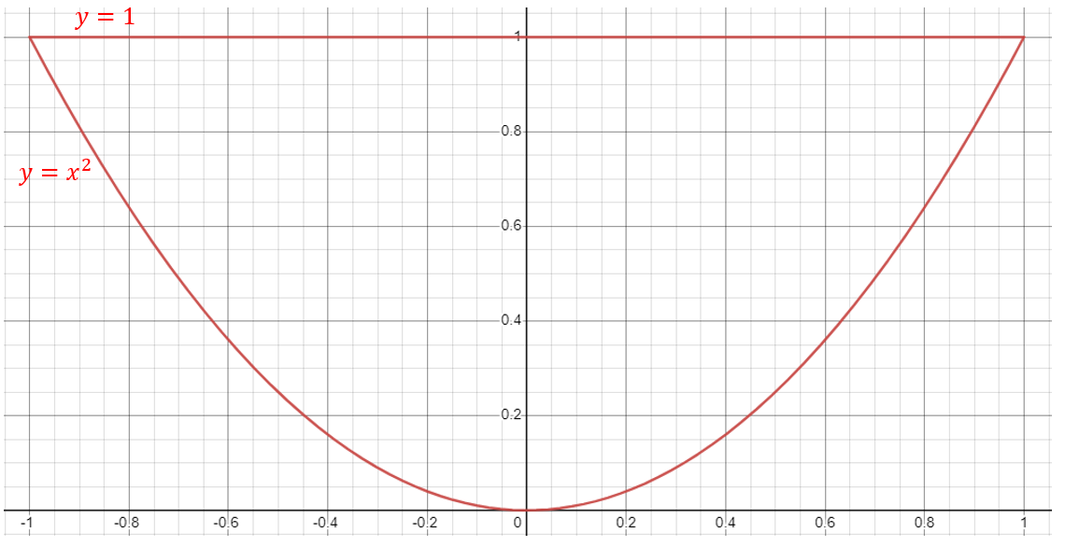

We have two choices to perform the integration. We can have the order of integration be [](https://www.codecogs.com/eqnedit.php?latex=dydx#0) (think of this as summing/integrating over the [](https://www.codecogs.com/eqnedit.php?latex=y#0) values in the inner integral and summing/integrating the [](https://www.codecogs.com/eqnedit.php?latex=x#0) values in the outer integral) or [](https://www.codecogs.com/eqnedit.php?latex=dxdy#0) (the opposite).

Here are some general considerations when choosing the order of integration:

* Coordinate system: Depending on the geometry of the region or the function being integrated, it might be easier to use a particular coordinate system (Cartesian, polar, cylindrical, or spherical). The choice of coordinate system can influence the order of integration.
* Integration limits: The order of integration can affect the limits of integration. In some cases, the limits of integration can be simpler or more complex depending on the order chosen. Try to choose an order that results in simpler limits, which can make the integration process more manageable.
* Function complexity: Analyze the integrand and determine whether the order of integration will make the function easier or more difficult to integrate. In some cases, integrating with respect to one variable first may simplify the integrand for the subsequent integral.
* Symmetry: If the function or region being integrated has symmetry, consider exploiting this property to simplify the integration. For example, if the region is symmetric about an axis or plane, you can integrate over half of the region and multiply the result by 2.
* Singularities and discontinuities: If the integrand has singularities or discontinuities, it may be beneficial to choose an order of integration that avoids these problematic points. This can help prevent issues with convergence and ensure the accuracy of the results.
* Computational efficiency: In some cases, the order of integration may affect the computational efficiency of the integration process. If you are using numerical integration methods, such as the Trapezoidal Rule or Simpson's Rule, it might be more efficient to integrate with respect to one variable before the other.
* Substitution or transformation: Sometimes, it is possible to simplify the integration process by performing a substitution or transformation, such as a change of variables. The order of integration can affect the ease of applying these techniques.

Let’s start with [](https://www.codecogs.com/eqnedit.php?latex=dydx#0) for no particular reason.

In order to determine the limits of integration, we can look back to the graph. In order to integrate over the entire region, we will first consider that we will integrate over the entire range of [](https://www.codecogs.com/eqnedit.php?latex=x#0) values as that is what will be on the outer integral. Then when thinking about the limits of integration on the inner integral, we will need to be aware of “where” we are in the summation/integration over the [](https://www.codecogs.com/eqnedit.php?latex=x#0) values. You can imagine yourself making your way across the [](https://www.codecogs.com/eqnedit.php?latex=x#0)-axis as the integration is taking place. At a particular [](https://www.codecogs.com/eqnedit.php?latex=x#0) value, the limits of [](https://www.codecogs.com/eqnedit.php?latex=y#0) depend on [](https://www.codecogs.com/eqnedit.php?latex=x#0) since we have [](https://www.codecogs.com/eqnedit.php?latex=x%5E2%20%5Cleq%20y%20%5Cleq%201#0). Imagine yourself standing on the [](https://www.codecogs.com/eqnedit.php?latex=x#0)-axis at a particular value. When looking up from a point on the [](https://www.codecogs.com/eqnedit.php?latex=x#0)-axis one should be able to see that we need to integrate from the parabola up to the horizontal line. We also need to put [](https://www.codecogs.com/eqnedit.php?latex=y#0) in terms of [](https://www.codecogs.com/eqnedit.php?latex=x#0). The [](https://www.codecogs.com/eqnedit.php?latex=y#0) values go from [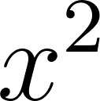](https://www.codecogs.com/eqnedit.php?latex=x%5E2#0) up to [](https://www.codecogs.com/eqnedit.php?latex=1#0). These will be the limits of integration for the inner integral.

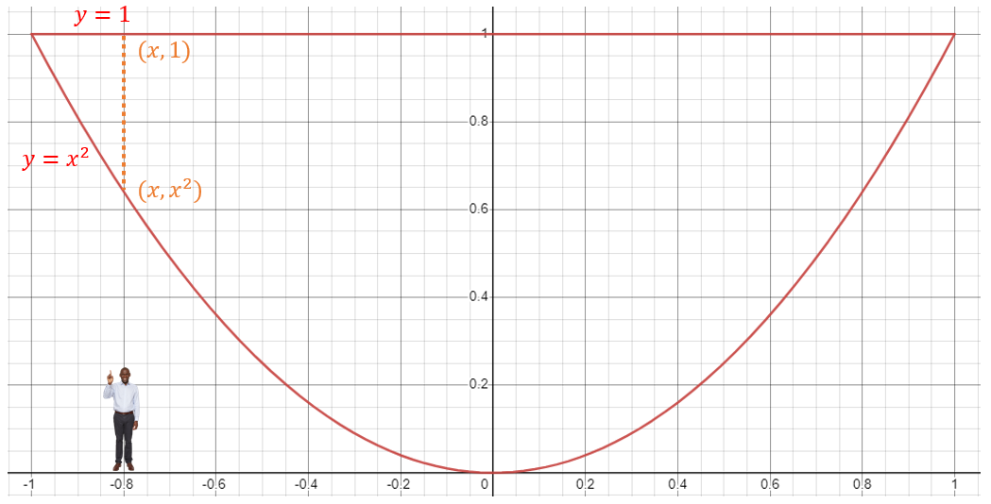

[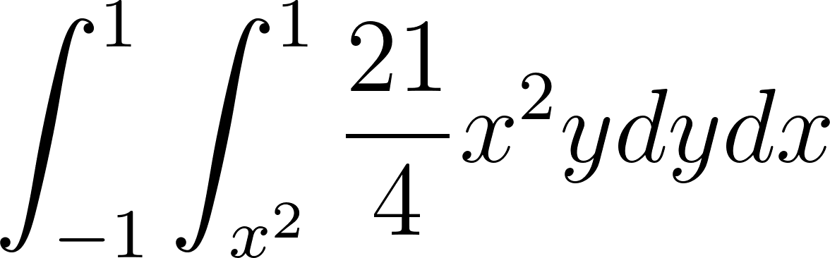](https://www.codecogs.com/eqnedit.php?latex=%5Cint_%7B-1%7D%5E1%20%5Cint_%7Bx%5E2%7D%5E1%20%5Cdfrac%7B21%7D%7B4%7Dx%5E2ydydx#0)

First let’s integrate the inner integral, we can move the [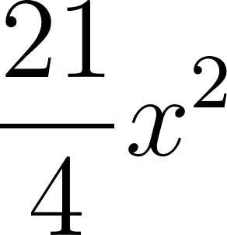](https://www.codecogs.com/eqnedit.php?latex=%5Cdfrac%7B21%7D%7B4%7Dx%5E2#0) term out as those are considered constant since we are integrating with respect to [](https://www.codecogs.com/eqnedit.php?latex=y#0).

[](https://www.codecogs.com/eqnedit.php?latex=%5Cdfrac%7B21%7D%7B4%7Dx%5E2%20%5Cint_%7Bx%5E2%7D%5E1ydy%3D%5Cdfrac%7B21%7D%7B4%7Dx%5E2%20%5Cbigg%5B%5Cdfrac%7By%5E2%7D%7B2%7D%20%5Cbigg%20%5Crvert_%7Bx%5E2%7D%5E1%20%5Cbigg%5D%3D%5Cdfrac%7B21%7D%7B4%7Dx%5E2%5Cbigg%5B%5Cdfrac%7B1%7D%7B2%7D-%5Cdfrac%7Bx%5E4%7D%7B2%7D%20%5Cbigg%5D%3D%5Cdfrac%7B21%7D%7B8%7Dx%5E2(1-x%5E4)#0)

Now we can integrate with respect to [](https://www.codecogs.com/eqnedit.php?latex=x#0).

[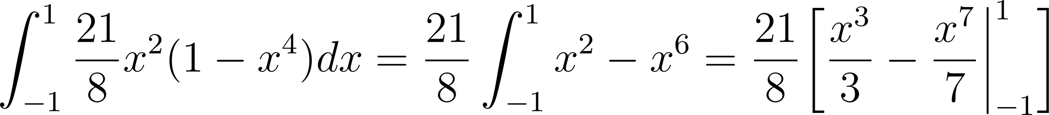](https://www.codecogs.com/eqnedit.php?latex=%5Cint_%7B-1%7D%5E1%20%5Cdfrac%7B21%7D%7B8%7Dx%5E2(1-x%5E4)dx%3D%5Cdfrac%7B21%7D%7B8%7D%5Cint_%7B-1%7D%5E1%20x%5E2-x%5E6%3D%5Cdfrac%7B21%7D%7B8%7D%5Cbigg%5B%5Cdfrac%7Bx%5E3%7D%7B3%7D-%5Cdfrac%7Bx%5E7%7D%7B7%7D%20%20%5Cbigg%20%5Crvert_%7B-1%7D%5E1%20%5Cbigg%5D#0)

[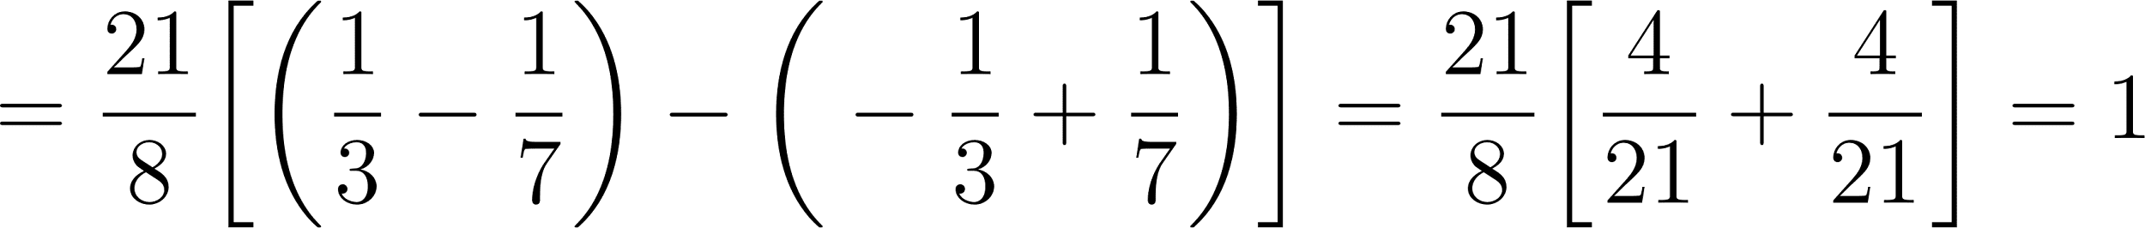](https://www.codecogs.com/eqnedit.php?latex=%3D%5Cdfrac%7B21%7D%7B8%7D%5Cbigg%5B%5Cbigg(%5Cdfrac%7B1%7D%7B3%7D-%5Cdfrac%7B1%7D%7B7%7D%20%5Cbigg)%20-%20%5Cbigg(-%5Cdfrac%7B1%7D%7B3%7D%2B%5Cdfrac%7B1%7D%7B7%7D%20%5Cbigg)%20%5Cbigg%5D%3D%5Cdfrac%7B21%7D%7B8%7D%5Cbigg%5B%20%5Cdfrac%7B4%7D%7B21%7D%2B%5Cdfrac%7B4%7D%7B21%7D%20%5Cbigg%5D%3D1#0)

Now we can try using [](https://www.codecogs.com/eqnedit.php?latex=dxdy#0).

In order to integrate over the entire region, we will first consider that we will integrate over the entire range of [](https://www.codecogs.com/eqnedit.php?latex=y#0) values as that is what will be on the outer integral. Then when thinking about the limits of integration on the inner integral, we will need to be aware of “where” we are in the summation/integration over the [](https://www.codecogs.com/eqnedit.php?latex=y#0) values. You can imagine yourself making your way up the [](https://www.codecogs.com/eqnedit.php?latex=y#0)-axis as the integration is taking place. At a particular [](https://www.codecogs.com/eqnedit.php?latex=y#0) value, the limits of [](https://www.codecogs.com/eqnedit.php?latex=x#0) depend on [](https://www.codecogs.com/eqnedit.php?latex=y#0) since we have [](https://www.codecogs.com/eqnedit.php?latex=x%5E2%20%5Cleq%20y%20%5Cleq%201#0). Imagine yourself climbing up the [](https://www.codecogs.com/eqnedit.php?latex=y#0)-axis at a particular value and looking to the left and right. When looking up from a point on the [](https://www.codecogs.com/eqnedit.php?latex=y#0)-axis one should be able to see that we need to integrate from the left side of the parabola to the right side of the parabola. We also need to put [](https://www.codecogs.com/eqnedit.php?latex=x#0) in terms of [](https://www.codecogs.com/eqnedit.php?latex=y#0). The [](https://www.codecogs.com/eqnedit.php?latex=x#0) values go from [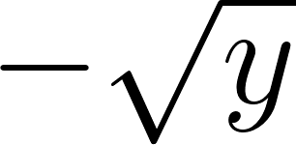](https://www.codecogs.com/eqnedit.php?latex=-%5Csqrt%7By%7D#0) over to [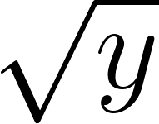](https://www.codecogs.com/eqnedit.php?latex=%5Csqrt%7By%7D#0). These will be the limits of integration for the inner integral.

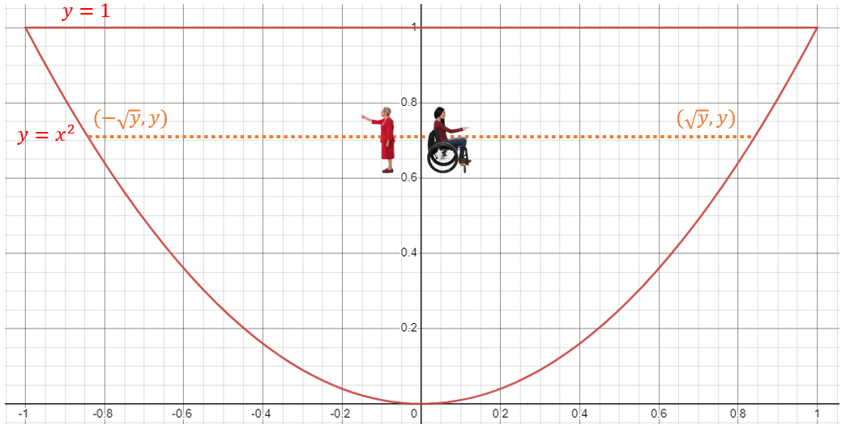

[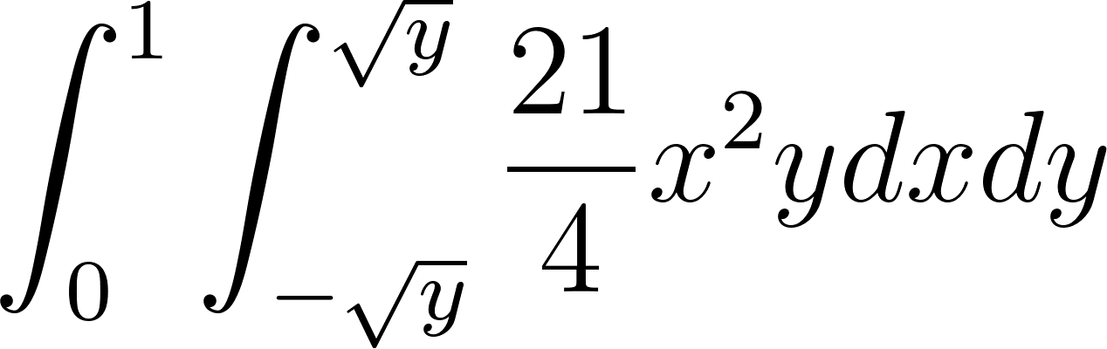](https://www.codecogs.com/eqnedit.php?latex=%5Cint_%7B0%7D%5E1%20%5Cint_%7B-%5Csqrt%7By%7D%7D%5E%7B%5Csqrt%7By%7D%7D%20%5Cdfrac%7B21%7D%7B4%7Dx%5E2ydxdy#0)

First let’s integrate the inner integral, we can move the [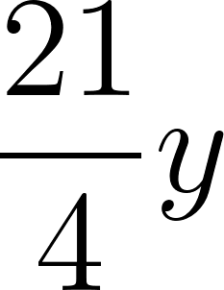](https://www.codecogs.com/eqnedit.php?latex=%5Cdfrac%7B21%7D%7B4%7Dy#0) term out as those are considered constant since we are integrating with respect to [](https://www.codecogs.com/eqnedit.php?latex=x#0).

[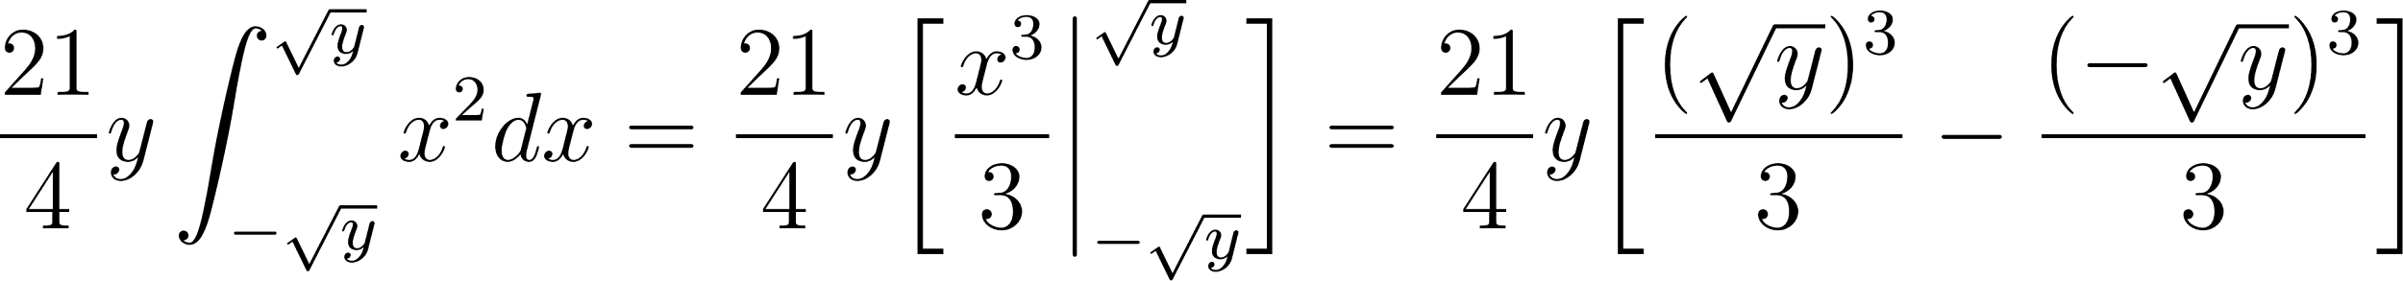](https://www.codecogs.com/eqnedit.php?latex=%5Cdfrac%7B21%7D%7B4%7Dy%5Cint_%7B-%5Csqrt%7By%7D%7D%5E%7B%5Csqrt%7By%7D%7Dx%5E2dx%3D%5Cdfrac%7B21%7D%7B4%7Dy%5Cbigg%5B%5Cdfrac%7Bx%5E3%7D%7B3%7D%20%5Cbigg%20%5Crvert_%7B-%5Csqrt%7By%7D%7D%5E%7B%5Csqrt%7By%7D%7D%20%5Cbigg%5D%3D%5Cdfrac%7B21%7D%7B4%7Dy%20%5Cbigg%5B%5Cdfrac%7B(%5Csqrt%7By%7D)%5E3%7D%7B3%7D%20-%20%5Cdfrac%7B(-%5Csqrt%7By%7D)%5E3%7D%7B3%7D%20%5Cbigg%5D#0)

[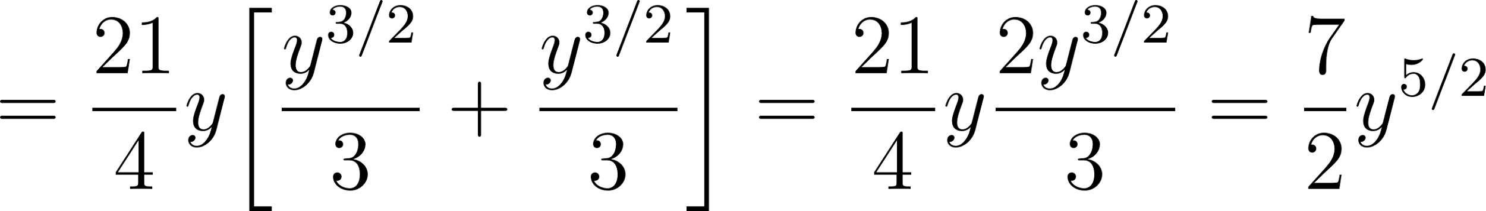](https://www.codecogs.com/eqnedit.php?latex=%3D%5Cdfrac%7B21%7D%7B4%7Dy%5Cbigg%5B%5Cdfrac%7By%5E%7B3%2F2%7D%7D%7B3%7D%2B%5Cdfrac%7By%5E%7B3%2F2%7D%7D%7B3%7D%20%5Cbigg%5D%3D%5Cdfrac%7B21%7D%7B4%7Dy%5Cdfrac%7B2y%5E%7B3%2F2%7D%7D%7B3%7D%3D%5Cdfrac%7B7%7D%7B2%7Dy%5E%7B5%2F2%7D#0)

Now we can integrate with respect to [](https://www.codecogs.com/eqnedit.php?latex=y#0)

[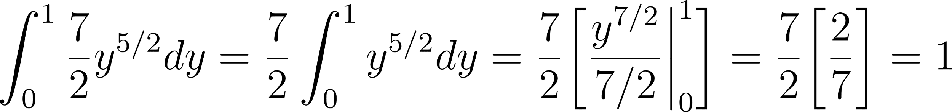](https://www.codecogs.com/eqnedit.php?latex=%5Cint_0%5E1%20%5Cdfrac%7B7%7D%7B2%7Dy%5E%7B5%2F2%7Ddy%3D%5Cdfrac%7B7%7D%7B2%7D%5Cint_0%5E1y%5E%7B5%2F2%7Ddy%3D%5Cdfrac%7B7%7D%7B2%7D%5Cbigg%5B%5Cdfrac%7By%5E%7B7%2F2%7D%7D%7B7%2F2%7D%20%5Cbigg%20%5Crvert_0%5E1%20%5Cbigg%5D%3D%5Cdfrac%7B7%7D%7B2%7D%20%5Cbigg%5B%5Cdfrac%7B2%7D%7B7%7D%20%5Cbigg%5D%3D1#0)

Both orders of integration result in a value of [](https://www.codecogs.com/eqnedit.php?latex=1#0) which verifies that the order of integration that can be used can go in either order and that the joint PDF is a valid PDF.

The computations of the marginals were already completed in the course of the two integrations. The marginal of [](https://www.codecogs.com/eqnedit.php?latex=X#0) ends up having bounds of [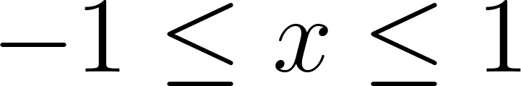](https://www.codecogs.com/eqnedit.php?latex=-1%20%5Cleq%20x%20%5Cleq%201#0) because the [](https://www.codecogs.com/eqnedit.php?latex=y#0) is “integrated out” leaving the [](https://www.codecogs.com/eqnedit.php?latex=x#0) values and as evidenced by the graph, [](https://www.codecogs.com/eqnedit.php?latex=x#0) can go from [](https://www.codecogs.com/eqnedit.php?latex=-1#0) to [](https://www.codecogs.com/eqnedit.php?latex=1#0). The same logic can be applied to the marginal of [](https://www.codecogs.com/eqnedit.php?latex=Y#0).

# Independence of Jointly Distributed Random Variables

The “funny limits” on the slide refer to non-rectangular limits that makes factoring into the separate marginals impossible. For example, in the previous example the limits were [](https://www.codecogs.com/eqnedit.php?latex=x%5E2%20%5Cleq%20y%20%5Cleq%201#0) which clearly shows some dependence between [](https://www.codecogs.com/eqnedit.php?latex=x#0) and [](https://www.codecogs.com/eqnedit.php?latex=y#0). Rectangular limits would look something like [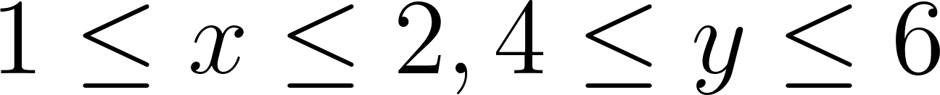](https://www.codecogs.com/eqnedit.php?latex=1%20%5Cleq%20x%20%5Cleq%202%2C%204%20%5Cleq%20y%20%5Cleq%206#0) which is a rectangular region to integrate over and the limits of integration are independent of each other.

## Independence Example 1

The value of [](https://www.codecogs.com/eqnedit.php?latex=c#0) here would be the constant that makes this a valid PDF. For the purposes of finding whether these are independent or not using the theorem from the slides, it will not affect the ability to rewrite [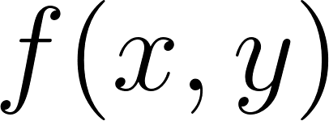](https://www.codecogs.com/eqnedit.php?latex=f(x%2Cy)#0) as a product of two functions. The limits are not “funny” as they are rectangular.

[](https://www.codecogs.com/eqnedit.php?latex=cxy#0) can be written as [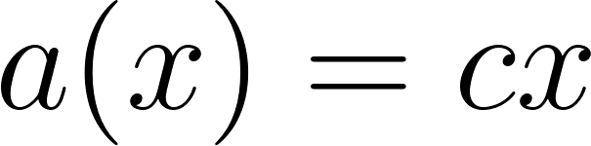](https://www.codecogs.com/eqnedit.php?latex=a(x)%3Dcx#0) and [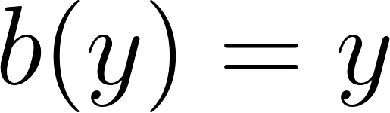](https://www.codecogs.com/eqnedit.php?latex=b(y)%3Dy#0) so [](https://www.codecogs.com/eqnedit.php?latex=f(x%2Cy)%3Da(x)b(y)%3Dcxy#0).

We can also verify this using the definition. In that case, it’s clearer if we find the value for [](https://www.codecogs.com/eqnedit.php?latex=c#0) first and then check whether [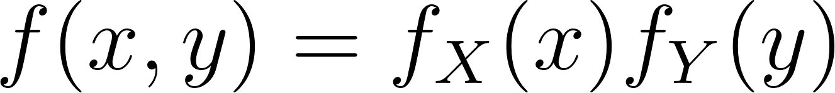](https://www.codecogs.com/eqnedit.php?latex=f(x%2Cy)%3Df_X(x)f_Y(y)#0)

[](https://www.codecogs.com/eqnedit.php?latex=%5Cint_0%5E2%5Cint_0%5E3%20cxy%20dydx%5Cint_0%5E2%20cx%20%5Cint_0%5E3%20ydy%3D%5Cint_0%5E2%20cx%20%5Cbigg%5B%5Cdfrac%7By%5E2%7D%7B2%7D%20%5Cbigg%20%5Crvert_0%5E3%20%5Cbigg%5D%3D%5Cint_0%5E2%20%5Cdfrac%7B9%7D%7B2%7Dcxdx%3D%5Cdfrac%7B9%7D%7B2%7Dc%5Cint_0%5E2%20xdx#0)

[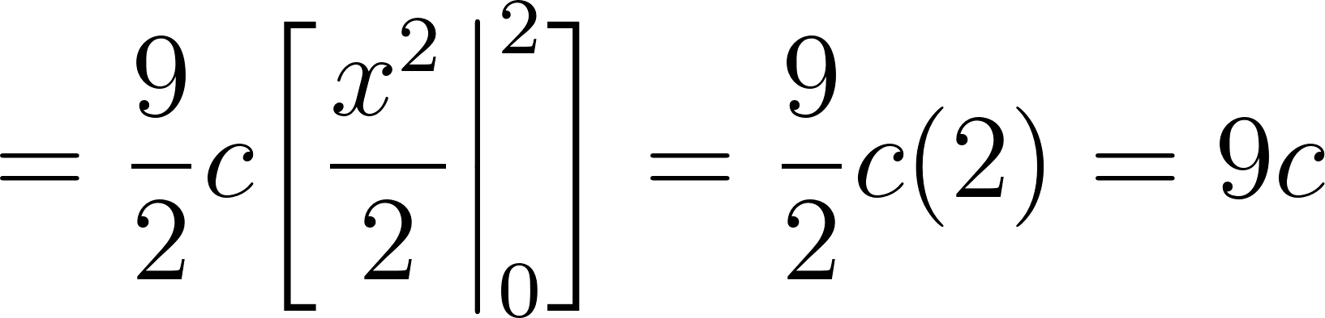](https://www.codecogs.com/eqnedit.php?latex=%3D%5Cdfrac%7B9%7D%7B2%7Dc%20%5Cbigg%5B%20%5Cdfrac%7Bx%5E2%7D%7B2%7D%20%5Cbigg%20%5Crvert_0%5E2%20%5Cbigg%5D%3D%5Cdfrac%7B9%7D%7B2%7Dc(2)%3D9c#0)

Set this equal to [](https://www.codecogs.com/eqnedit.php?latex=1#0) and solve for [](https://www.codecogs.com/eqnedit.php?latex=c#0) gives us [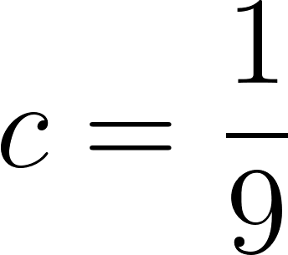](https://www.codecogs.com/eqnedit.php?latex=c%3D%5Cdfrac%7B1%7D%7B9%7D#0).

Now we can find the marginals [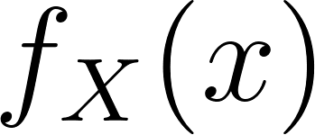](https://www.codecogs.com/eqnedit.php?latex=f_X(x)#0) and [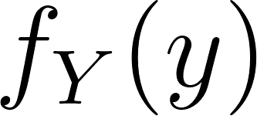](https://www.codecogs.com/eqnedit.php?latex=f_Y(y)#0).

The marginal of [](https://www.codecogs.com/eqnedit.php?latex=X#0) is [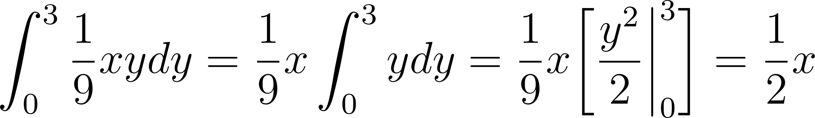](https://www.codecogs.com/eqnedit.php?latex=%5Cint_0%5E3%20%5Cdfrac%7B1%7D%7B9%7Dxy%20dy%3D%5Cdfrac%7B1%7D%7B9%7Dx%20%5Cint_0%5E3%20ydy%3D%5Cdfrac%7B1%7D%7B9%7Dx%20%5Cbigg%5B%5Cdfrac%7By%5E2%7D%7B2%7D%20%5Cbigg%20%5Crvert_0%5E3%20%5Cbigg%5D%3D%5Cdfrac%7B1%7D%7B2%7Dx#0)

The marginal of [](https://www.codecogs.com/eqnedit.php?latex=Y#0) is [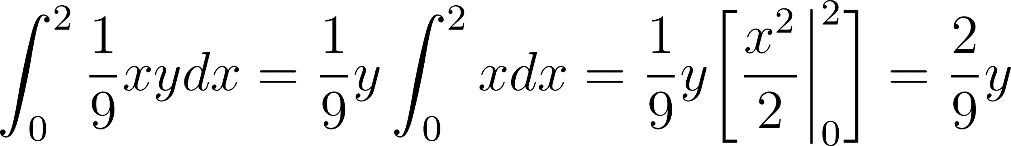](https://www.codecogs.com/eqnedit.php?latex=%5Cint_0%5E2%20%5Cdfrac%7B1%7D%7B9%7Dxy%20dx%3D%5Cdfrac%7B1%7D%7B9%7Dy%20%5Cint_0%5E2%20xdx%3D%5Cdfrac%7B1%7D%7B9%7Dy%20%5Cbigg%5B%5Cdfrac%7Bx%5E2%7D%7B2%7D%20%5Cbigg%20%5Crvert_0%5E2%5Cbigg%5D%3D%5Cdfrac%7B2%7D%7B9%7Dy#0)

Multiplying [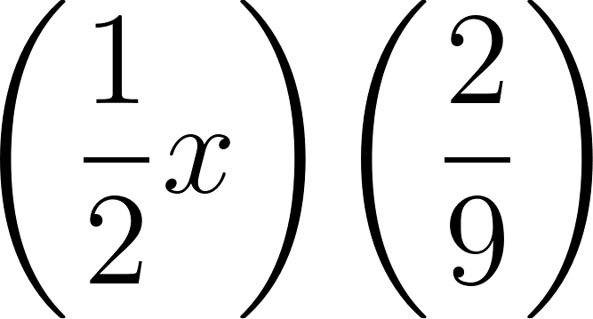](https://www.codecogs.com/eqnedit.php?latex=%5Cbigg(%5Cdfrac%7B1%7D%7B2%7Dx%20%5Cbigg)%5Cbigg(%5Cdfrac%7B2%7D%7B9%7D%20%5Cbigg)#0) results in [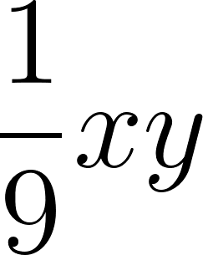](https://www.codecogs.com/eqnedit.php?latex=%5Cdfrac%7B1%7D%7B9%7Dxy#0) which is [](https://www.codecogs.com/eqnedit.php?latex=f(x%2Cy)#0)

## Independence Example 2

There’s no need to do any checking here as we can immediately rule out independence due to the “funny limits”

## Independence Example 3

There’s no need to do any checking here as we can immediately rule out independence since there is no way to rewrite [](https://www.codecogs.com/eqnedit.php?latex=f(x%2Cy)#0) as a product of [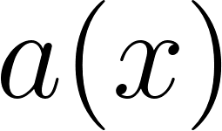](https://www.codecogs.com/eqnedit.php?latex=a(x)#0) and [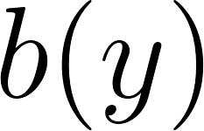](https://www.codecogs.com/eqnedit.php?latex=b(y)#0)

# Conditional PDF of Jointly Distributed Random Variables

Note that the bounds [](https://www.codecogs.com/eqnedit.php?latex=x%5E2%20%5Cleq%20y%20%5Cleq%201#0) are maintained here because by definition the numerator of [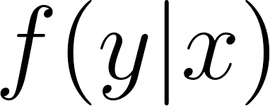](https://www.codecogs.com/eqnedit.php?latex=f(y%7Cx)#0) contains the joint distribution [](https://www.codecogs.com/eqnedit.php?latex=f(x%2Cy)#0) so the bounds on the variables must always be the same as [](https://www.codecogs.com/eqnedit.php?latex=f(x%2Cy)#0).

# Conditional Expectation of Jointly Distributed Random Variables

From prior work and from prior slides, [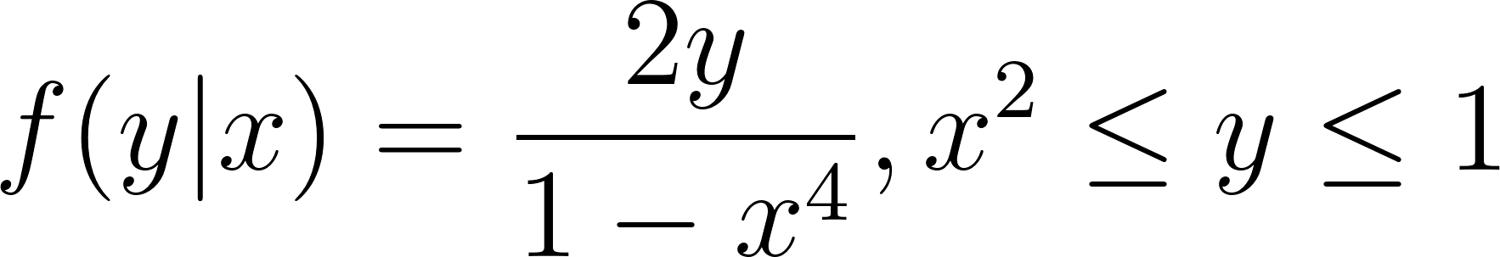](https://www.codecogs.com/eqnedit.php?latex=f(y%7Cx)%3D%5Cdfrac%7B2y%7D%7B1-x%5E4%7D%2C%20x%5E2%20%5Cleq%20y%20%5Cleq%201#0)

[](https://www.codecogs.com/eqnedit.php?latex=E%5BY%7Cx%5D%3D%5Cint_%7Bx%5E2%7D%5E1%20y%20%5Cdfrac%7B2y%7D%7B1-x%5E4%7Ddy%3D%5Cint_%7Bx%5E2%7D%5E1%20%5Cdfrac%7B2y%5E2%7D%7B1-x%5E4%7Ddy%3D%5Cdfrac%7B1%7D%7B1-x%5E4%7D%5Cint_%7Bx%5E2%7D%5E12y%5E2%20dy#0)

[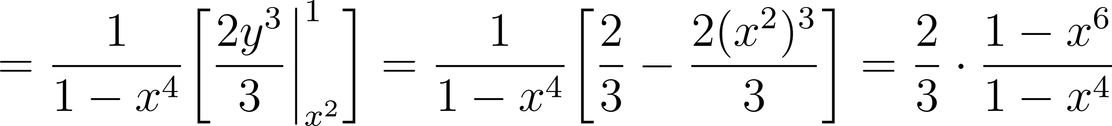](https://www.codecogs.com/eqnedit.php?latex=%3D%5Cdfrac%7B1%7D%7B1-x%5E4%7D%5Cbigg%5B%20%5Cdfrac%7B2y%5E3%7D%7B3%7D%20%5Cbigg%20%5Crvert_%7Bx%5E2%7D%5E1%20%5Cbigg%5D%3D%5Cdfrac%7B1%7D%7B1-x%5E4%7D%20%5Cbigg%5B%5Cdfrac%7B2%7D%7B3%7D-%5Cdfrac%7B2(x%5E2)%5E3%7D%7B3%7D%20%5Cbigg%5D%3D%5Cdfrac%7B2%7D%7B3%7D%20%5Ccdot%20%5Cdfrac%7B1-x%5E6%7D%7B1-x%5E4%7D#0)